GRADE 1 • STORY
Nia’s Language Hunt
Listen • Read • Notice
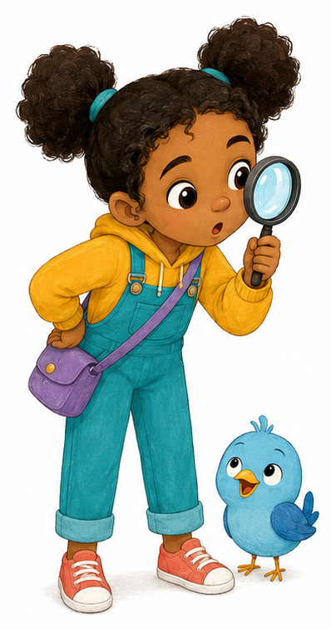

PLACE | WORDS NIA HEARS
HOME | “Hello!” says Dad.
SCHOOL | “Open your book,” says the teacher.
SCREEN | “Press play!” says the game.
OUTSIDE | “Welcome!” says the sign.
PIP ASKS Can words live in more than one place?
Nia smiles. “Words are everywhere!”
GRADE 1 • ACTIVITY
My Word Hunt
Point • Match • Draw • Say
TODAY I CAN notice where I hear English.
PLACE | WORDS
Home | Good morning!
School | Write your name.
Screen | Choose a player.
Outside | Close the gate.

Draw and tell Pip
Choose one place. Draw a word or sound you hear there.
______________________________________________________
______________________________________________________
______________________________________________________
Say: “I hear English at ______.”
EXIT Circle one: HOME SCHOOL SCREEN OUTSIDE

GRADE 1 • STORY
The Hidden Card
Nia and Pip • Lesson 2
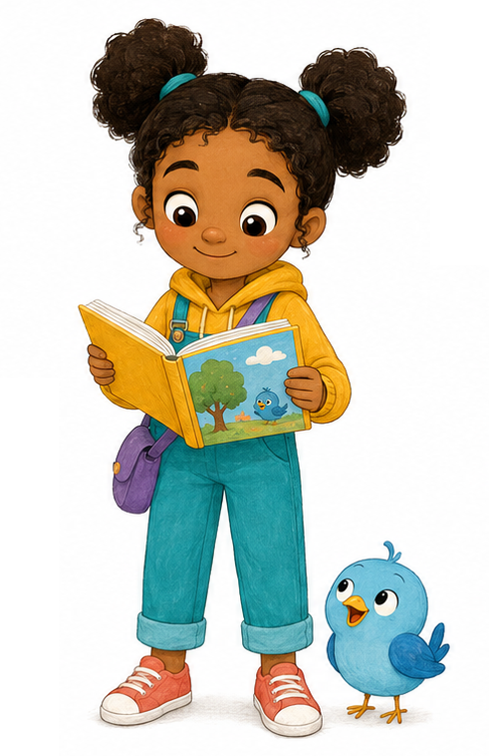

Nia lifts the card. It is a MIRROR.
Nia sees her face. Pip sees his blue feathers.
On the card is one word: YOU.
“Words live with people too!” says Nia.
Nia says, “My name is Nia. I like stories.”
Pip chirps, “My name is Pip. I like songs!”
PIP ASKS What words tell something about you?
GRADE 1 • ACTIVITY
The Mirror Card
Draw • Circle • Say
TODAY I CAN say or draw words that tell something about me—or an invented character.

1. Draw
Draw yourself or make up a character inside the mirror.

2. Circle and finish
I like: STORIES SONGS GAMES ANIMALS DRAWING
My name is ____________________.
I like ____________________.
TELL PIP “My name is ______. I like ______.”

GRADE 1 • STORY
One Word, Different Voices
Nia and Pip • Lesson 3
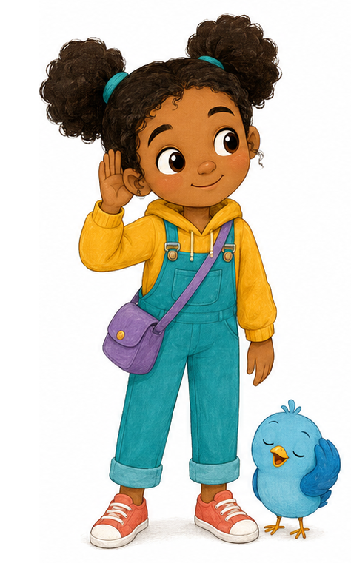

VOICE 1 | VOICE 2
Hello! | Hello!
“They both said HELLO!” says Nia.
One voice was quick. One voice was slow.
Pip flaps his wings. “Different sound. Same kind word!”
Nia listens to the voices around her. Some are high. Some are low. Some words have different beats.
“Every voice is welcome,” says Nia.
SAY IT TOGETHER Different voices can share the same word.
GRADE 1 • ACTIVITY
Listen Like Pip
Listen • Circle • Say
TODAY I CAN hear the same familiar word in different voices.

1. Listen and circle
Your teacher says two words. Circle SAME or DIFFERENT.
PAIR | YOUR ANSWER
1 | SAME DIFFERENT
2 | SAME DIFFERENT
3 | SAME DIFFERENT

2. Match the word
Listen. Draw a line to the word you hear.
HELLO | THANK YOU | GOODBYE
○ | ○ | ○

3. Draw the speakers
Draw two people saying the same friendly word.
TELL PIP “The voices sound different. The word is the same.”

GRADE 1 • STORY
One Word, Two Pictures
Nia and Pip • Lesson 4
 | 
FOOTBALL | FOOTBALL
“Two footballs?” asks Pip.
Nia nods. “The word can point to different games in different places.”
Pip looks again. The pictures are different. The word is the same.
“I can ask, Which game do you mean?” says Pip.
SAY IT TOGETHER Same word. Different pictures. Ask for a clue!
GRADE 1 • ACTIVITY
Pip’s Picture Clues
Look • Circle • Ask
TODAY I CAN look for a clue and ask what a word means.

1. Look again
FOOTBALL | FOOTBALL
Circle: SAME WORD DIFFERENT WORDS
Circle: SAME PICTURE DIFFERENT PICTURES

2. Draw your clue
Choose one football picture. Add one clue: a goal, a field, a player or a rule.
ASK “Which game do you mean?”

GRADE 1 • STORY
The Great Language Map
Nia and Pip • Lesson 5
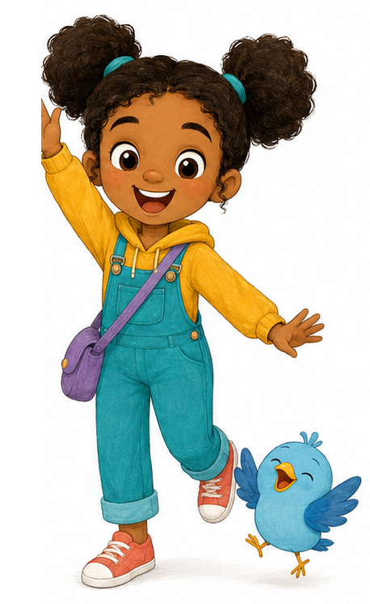

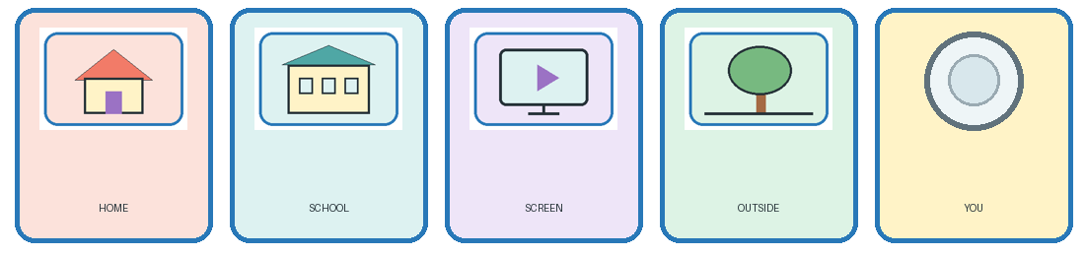
Nia catches HOME. Pip finds SCHOOL.
SCREEN lands by a chair. OUTSIDE sticks to a tree.
The shiny YOU card lands last.
“We found where words live,” says Nia. “We found words about people too.”
Pip chirps, “We listened to different voices and asked for clues!”
NIA SAYS Now we can build our own language map.
GRADE 1 • FINAL MISSION
My Language Map
Draw • Point • Tell
TODAY I CAN show where words live and tell Pip one thing I learned.

1. Complete the five cards
Draw one small clue in each card.
HOME | SCHOOL | SCREEN | OUTSIDE | YOU

2. Choose and say
Point to one card. Finish one sentence:
“I hear English at __________.” “One word I know is __________.”
“If I am unsure, I can ask __________________________________.”
UNIT 1 COMPLETE I can look, listen and ask for clues!

